Amazon River, Brazil

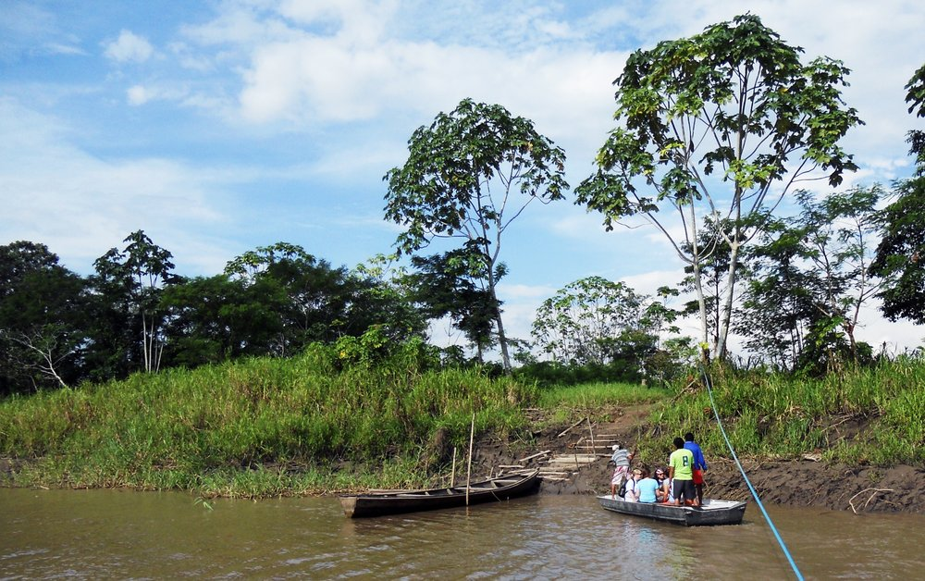

TRIP DATES: August/September – Dates TBD
APPLICATIONS DUE: Feb 12th Apply Here or go to https://onechapel.com/short-term-missions
COST: $2,700-3,300 (includes airfare)
PAYMENT DUE: $100 - Feb 12th; $300 - May 12th; $600 - June 12th; Balance due August 1st
LEADERS: Richard Jennings (512-750-6470) and Christi Jennings (512-423-3004
GROUP SIZE: 12-16
ACCOMMODATIONS: Riverboat - Separate rooms/baths. All in-country meals and transportation.
INFO: Our mission is to bring the hope of Christ to the people living in the West Amazon Basin through evangelism, medical/dental clinics, VBS and discipleship. Our objectives are to learn to share the gospel in a cross-cultural setting, see God at work in a new way, and grow to a new level of servanthood and dependency on God. Depending on the makeup of the team, we may have a medical and or dental clinic. The location will be outside of Manacaparu. We will fly to Manaus, Brazil, then get onto a bus and travel to Manacaparu. There we will board the boat and travel by water to the village. We will spend approximately 5 nights and 6 days on the boat and in village ministering and then will travel back to Manaus, spending one night in Manaus and then flying home.

REQUIREMENTS: Attend all meetings and training classes (meeting schedule TBD), join our prayer and devotions, raise support, and enlist prayer partners.
Passport and Malaria Prevention.

Recommended: Typhoid and Yellow Fever Immunizations.
*Visa to enter country may be required.
*Final cost may fluctuate due to travel. Teams will be notified.

